
CRSPE
Canton Regional Society of Professional Engineers
Thursday, March 15, 2012
Shady Hollow Country Club
4685 Wales Road, N.W., Massillon, OH

Legislative Night

Registration Requirements for Educators
Nils (Rik) Nilsson, P.E.
Past President, OSPE

Former HB 592 provided that engineering professors who teach or are in responsible charge of teaching engineering curriculum which could affect the health, safety and welfare of the public should be required to be registered. It is proposed that a similar bill will be submitted to the Ohio legislature again this year. Find out the details of this proposed legislation and where it stands today.

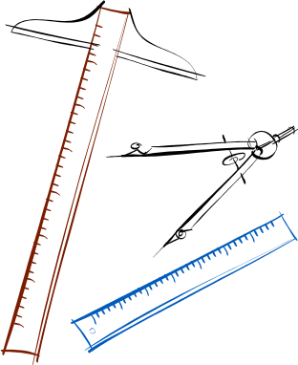
5:30 pm - Cash Bar
6:00 pm – Dinner (Buffet)
6:45 pm - Program

Cost = $20 per person
(payable at the door)

1 CPD Hour

For reservations contact Rick Buchanan at (330) 497-8250 or at rlbuchanan@att.net no later than Tuesday, March 13.

